Tab A:

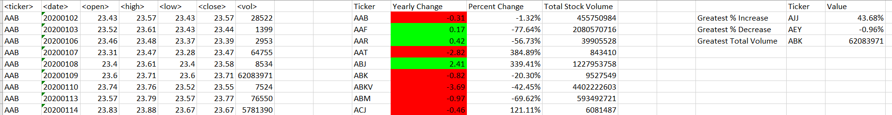

Tab B:

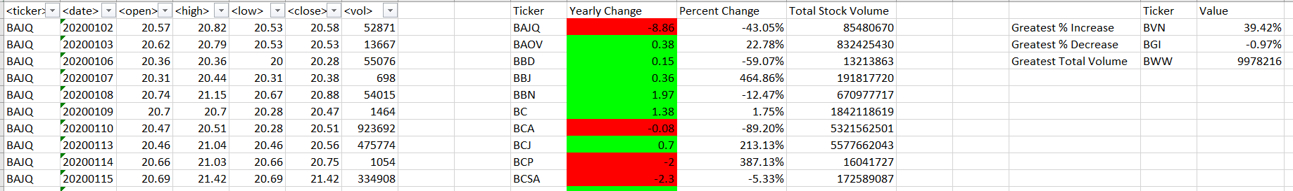

Tab C:

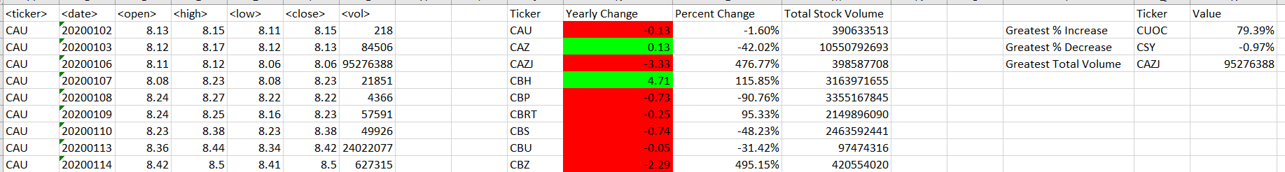

Tab D:

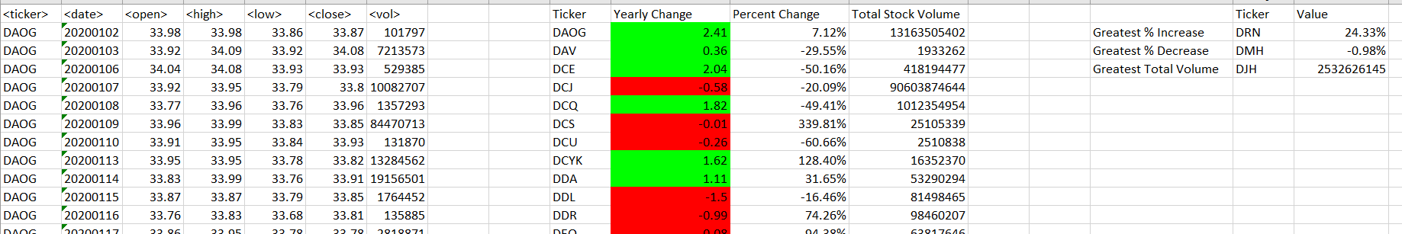

Tab E:

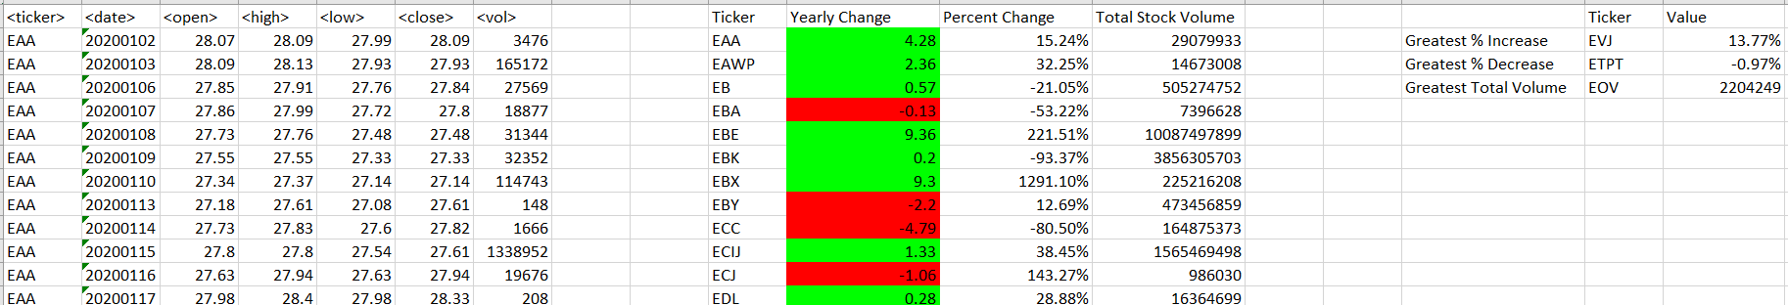

Tab F:

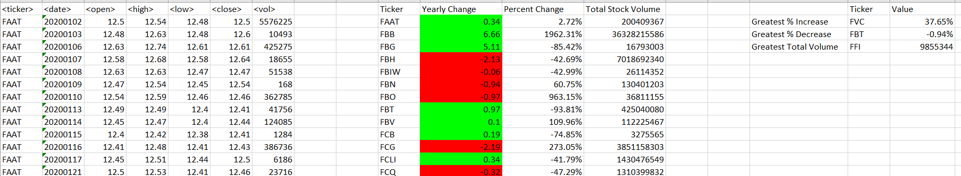

**Read me:**

I relied heavily on the *Home and Learn* materials as well as several YouTube videos to complete this challenge. I ran the scripts and asked for clarification through ChatGPT to check accuracy also.

I did not combine the data for the final results, but I would have used PowerQuery to append the alphabetical data since I am very familiar with that tool. Eyeballing the data for the year 2020 above, the stock with the; Greatest % Increase was CUOC; Greatest % Decrease was DMH; and Greatest Total Volume was DJH.